A Project Report

*On*

**AIRLINE RESERVATION SYSTEM**

*By*

Ankit Bhawsar (307015)

Anup Bandawar (307011)

Omkar Aurangabadkar (307008)

*Under the guidance of*

**B.P. Vasgi**



**Department of Information Technology**

**Sinhgad College of Engineering**

**SAVITRIBAI PHULE PUNE UNIVERSITY**

**2017-2018**

|  |  |
| --- | --- |
| Sinhgad Technical Education Society,  Department of Information Technology  Sinhgad College of Engineering , Pune-41 |  |

Date:

**CERTIFICATE**

This is to certify that,

Ankit Bhawsar (307015)

Anup Bandawar (307011)

Omkar Aurangabadkar (307008)

of class T.E IT; have successfully completed their project work on “Airline Reservation System” at SINHGAD COLLEGE OF ENGINEERING in the partial fulfillment of the Graduate Degree course in T.E at the Department of Information Technology, in the academic Year 2017-2018 Semester – I as prescribed by the Savitribai Phule Pune University.

B.P. Vasgi Prof.G. R. Pathak

Guide Head of the Department

(Department of Information Technology)

**Acknowledgement**

I feel great pleasure in expressing my deepest sense of gratitude and sincere thanks to my guide **B.P. Vasgi** for her valuable guidance during the Project work, without which it would have been very difficult task. I have no words to express my sincere thanks for valuable guidance, extreme assistance and cooperation extended to all the **Staff Members** of my Department.

This acknowledgement would be incomplete without expressing my special thanks to **Prof.G. R. Pathak** Head of the Department (Information Technology) for their support during the work.

I would also like to extend my heartfelt gratitude to my **Principal, Dr. S. D. Lokhande** who provided a lot of valuable support, mostly being behind the veils of college bureaucracy.

Last but not least I would like to thanks all the Teaching, Non- Teaching staff members of my Department, my parent and my colleagues those who helped me directly or indirectly for completing of this Project successfully.

Ankit Bhawsar

,

**Contents**

1. **TITLE OF THE PROJECT**
2. **ABSTRACT**
3. **INTRODUCTION**

* Problem definition

1. **SCOPE**
2. **SPECIFIC REQUIRMENTS**

* Hardware Interface
* Software Interface

1. **THEORY OF SOFTWERE USED**

* Java (JDK)
* MYSQL

1. **DATABASE SCHEMA**
2. **EER DIAGRAM**
3. **OUTPUT SCREEN (GUI)**
4. **SAMPLE CODE**
5. **CONCLUSION**
6. **REFERENCES**

**2. ABSTRACT**

Airline reservation System is a computerized system used to store and retrieve information and conduct transactions related to air travel. The project is aimed at exposing the relevance and importance of Airline Reservation Systems. It is projected towards enhancing the relationship between customers and airline agencies through the use of Database Management Systems (DBMS) and an interactive, user-friendly interface, and thereby making it convenient for the customers to book the flights as and when they require such that they can utilize this software to make reservations. This software has two parts: A back-end comprised of My-Sql Database, where all relevant data is stored, and an innovative front-end made up of jForms using Java.

The Software is made with two types of clientele in mind: customer and administrator. Administrator accounts are used by airline authorities. They can use this software in order to avail a large number of functionalities, such as creating a chartered flight, setting ticket costs, blocking or banning disruptive customers, adding locations for flights, and also cancelling said flights. Customers on the other hand can user this software to easily book tickets for flights and print said ticket at the touch of a button. Customers can use various methods to pay for tickets such as credit cards, net banking and also an inbuilt credit system managed by the software, allowing them to book airline tickets with ease and comfort.

Customers and Administrators each have their own login pages by which they can access the functionalities of the website. Any new customers will have to register for an account before they can go ahead to their home page. Admin Accounts on the other hand, can only be created using existing admin accounts so as to prevent unapproved creation of flights. Once logged in, user can seamlessly navigate through the website to book tickets, cancel tickets, print tickets, and update account details.

**3. INTRODUCTION**

**3.1 Existing System**

Currently there are many different methods available of booking airline tickets which include buying tickets online at airline websites, airports, brokers, travel agencies, etc. All these systems seem to be outdated. Most of these methods prey on the customers, making them waste time in lines or even pay surcharges and broker fees.

What we have attempted to do is close the gap between airline and end-user, and thereby eliminating the use of middle-men. Customers can buy tickets directly from the Airline Companies without having to pay any extra rates or charges. They can also directly compare flight prices offered by various airlines at the same time and choose the ticket at the best possible price.

**3.2 Problem Definition**

To develop a computerized reservation system meeting the rising customer interest in booking airline reservations. The system should be convenient, user-friendly and available to users as well as Airline companies.

The system should allow Airline Companies or ‘Admins’ to create new flights by specifying various parameters such as date, time, source, destination, number of seats, airplane used as well as stating amount of seats being offered to customers and the price of each of them.

The System should allow the user or customer to view entire flight information of the flight, book tickets, view or print tickets and if required, cancel tickets, upon which they should be eligible for a refund.

**4. SCOPE**

Airline Reservation System make the life of passengers very easy as they don’t need to stand in queues for getting their seats reserved and they can easily make reservations on any airline just from a single system. The primary aim of the system is to speed up transactions. Messages are displayed in message boxes to make the system user friendly. The main advantage of the system is the reduction in labor as it will possible so search the details of various places. This Airline Reservation System helps both Passenger as well as Admin by giving different functionalities.

**5. SPECIFIC REQUIRMENTS**

The proposed system analysis contains a planning and design phases where a logical design of system is developed and to work accordingly a plan is established. Also the requirements of system are identified and the operating environment is identified.

* Hardware
  + A computer acting as a Host and Server
* Software
  + MySQL Server
  + Java to MySql Driver
  + NetBeans IDE 8.2

**6. THEORY OF SOFTWERE USED**

**JAVA**

Java is a programming language originally developed by James Gosling at Sun Microsystems (which is now a subsidiary of Oracle Corporation) and released in 1995 as a core component of Sun Microsystems’ Java platform. The language derives much of its syntax from C and C++ but has a simpler object model and fewer low-level facilities. Java applications are typically compiled to bytecode (class file) that can run on any Java Virtual Machine (JVM) regardless of computer architecture. Java is a general-purpose, concurrent, class-based, object-oriented language that is specifically designed to have as few implementation dependencies as possible. It is intended to let application developers “write once, run anywhere”. The java is independent to platform so it’s important. Java is currently one of the most popular programming languages in use, and is widely used from application software to web applications.

James Gosling, Mike Sheridan, and Patrick Naughton initiated the Java language project in June 1991. Java was originally designed for interactive television, but it was too advanced for the digital cable television industry at the time. The language was initially called Oak after an oak tree that stood outside Gosling’s office; it went by the name Green later, and was later renamed Java, from a list of random words. Gosling aimed to implement a virtual machine and a language that had a familiar C/C++ style of notation.

Java is an object-oriented programming language developed by Sun Microsystems in 1990s. Since then, Java has gained enormous popularity as a computer language. Java was chosen as the programming language for network computers. It is a universal front end for enterprise database. Sun Microsystems states that, “Java is a simple, object-oriented, distributed, secure, architecture, robust, multi-threaded and dynamic language. The program can be written once, and run anywhere”. One of the most significant advantages of Java is that, it has the ability to move easily from one computer to another. It also has the ability to run the same program on many different operating systems. With such exemplary benefits, Java is a hot favourite among techies and software professionals it allows you to create modular programs and reusable codes .

**Java Features**   
  
**1] Simple, Small and familiar**  
Java is a simple and small language. The Syntax of java is just like c++, so it is very easy to learn. It is simple because it   
i) does not use header files  
ii) eliminated the use of pointer  
iii) operator overloading and virtual base classes are eliminated.  
  
**2] Object oriented**  
Java is a pure Object oriented . everything in java is object. all programs and data reside inside objects and classes

**3] Distributed**  
Java has networking facilities. so java can create application on network.

**4] Robust**  
java gives importance to memory management by using the technique called Garbage Collection and Exception handling.

**5] Secure**   
since java is used on internet, security is an important issue. A security code is asked before a java code is interpreted on internet.

**6] Platform independent**  
Java compiler generates an platform independent code called bytecode.   
  
**7] Portable**  
The Bytecode generated by java can be used on any machine. So it can be portable.  
  
**8] Compiled and Interpreted**  
Generally computer languages are either complied or interpreted. but java combines both compiler and interpreted.   
  
**9] High performance**  
The use of bytecode makes the performance high. the speed is also high with comparing c, c++.  
  
**10] Multithreading and interactive**Multithreading means handling more than one job at a time. Java supports Multithreading.  
  
**11] Dynamic and extensible**  
Java is a dynamic language. So it is capable of linking dynamic new classes, methods and objects. Java supports functions wriiten in c and c++ also.These functions are called native methods. During Run-Time Native methods can be linked dynamically.

**MySQL Database**

MySQL is an [open-source](https://en.wikipedia.org/wiki/Open-source) [relational database management system](https://en.wikipedia.org/wiki/Relational_database_management_system) (RDBMS). Its name is a combination of “My”, the name of co-founder [Michael Widenius](https://en.wikipedia.org/wiki/Michael_Widenius)’ daughter, and “[SQL](https://en.wikipedia.org/wiki/SQL)”, the abbreviation for [Structured Query Language](https://en.wikipedia.org/wiki/Structured_Query_Language). The MySQL development project has made its [source code](https://en.wikipedia.org/wiki/Source_code) available under the terms of the [GNU General Public License](https://en.wikipedia.org/wiki/GNU_General_Public_License), as well as under a variety of [proprietary](https://en.wikipedia.org/wiki/Proprietary_software) agreements. MySQL was owned and sponsored by a single [for-profit](https://en.wikipedia.org/wiki/Business) firm, the [Swedish](https://en.wikipedia.org/wiki/Sweden) company [MySQL AB](https://en.wikipedia.org/wiki/MySQL_AB), now owned by [Oracle Corporation](https://en.wikipedia.org/wiki/Oracle_Corporation). For proprietary use, several paid editions are available, and offer additional functionality.

MySQL is a central component of the [LAMP](https://en.wikipedia.org/wiki/LAMP_(software_bundle)) open-source web application software stack (and other “[AMP](https://en.wikipedia.org/wiki/List_of_AMP_packages)” stacks). LAMP is an acronym for “[Linux](https://en.wikipedia.org/wiki/Linux), [Apache](https://en.wikipedia.org/wiki/Apache_HTTP_Server), MySQL, [Perl](https://en.wikipedia.org/wiki/Perl)/[PHP](https://en.wikipedia.org/wiki/PHP)/[Python](https://en.wikipedia.org/wiki/Python_(programming_language))”. Applications that use the MySQL database include: [TYPO3](https://en.wikipedia.org/wiki/TYPO3), [MODx](https://en.wikipedia.org/wiki/MODx" \o "MODx), [Joomla](https://en.wikipedia.org/wiki/Joomla), [WordPress](https://en.wikipedia.org/wiki/WordPress), [Simple Machines Forum](https://en.wikipedia.org/wiki/Simple_Machines_Forum), [phpBB](https://en.wikipedia.org/wiki/PhpBB" \o "PhpBB), [MyBB](https://en.wikipedia.org/wiki/MyBB" \o "MyBB), and [Drupal](https://en.wikipedia.org/wiki/Drupal). MySQL is also used in many high-profile, large-scale [websites](https://en.wikipedia.org/wiki/Website), including [Google](https://en.wikipedia.org/wiki/Google) (though not for searches), [Facebook](https://en.wikipedia.org/wiki/Facebook), [Twitter](https://en.wikipedia.org/wiki/Twitter),  [Flickr](https://en.wikipedia.org/wiki/Flickr), and [YouTube](https://en.wikipedia.org/wiki/YouTube).

**SQL** is the most popular language for adding, accessing and managing content in a database. It is most noted for its quick processing, proven reliability, ease and flexibility of use. **MySQL**is an essential part of almost every open source **PHP** application.

**5.2.1 MySQL Features**

1. **Easy to use:**

MySQL is easy to use. You have to get only the basic knowledge of SQL. You can build and interact with MySQL with only a few simple SQL statements.

1. **It is secure:**

MySQL consist of a solid data security layer that protects sensitive data from intruders. Passwords are encrypted in MySQL.

1. **Client/ Server Architecture:**

MySQL follows a client /server architecture. There is a database server (MySQL) and arbitrarily many clients (application programs), which communicate with the server; that is, they query data, save changes, etc.

1. **Free to download:**

MySQL is free to use and you can download it from MySQL official website.

1. **It is scalable:**

MySQL can handle almost any amount of data, up to as much as 50 million rows or more. The default file size limit is about 4 GB. However, you can increase this number to a theoretical limit of 8 TB of data.

1. **Compatibale on many operating systems:**

MySQL is compatible to run on many operating systems, like Novell NetWare, Windows* Linux*, many varieties of UNIX* (such as Sun* Solaris*, AIX, and DEC* UNIX), OS/2, FreeBSD*, and others. MySQL also provides a facility that the clients can run on the same computer as the server or on another computer (communication via a local network or the Internet).

1. **Allows roll-back:**

MySQL allows transactions to be rolled back, commit and crash recovery.

1. **High Performance:**

MySQL is faster, more reliable and cheaper because of its unique storage engine architecture.

1. **High Flexibility:**

MySQL supports a large number of embedded applications which makes MySQL very flexible.

1. **High Productivity:**

MySQL uses Triggers, Stored procedures and views which allows the developer to give a higher productivity.

7. **DATABASE SCHEMA**

* 1. **admin**

|  |  |  |  |  |
| --- | --- | --- | --- | --- |
| **Column** | **Type** | **Null** | **Key** | **Default** |
| admin_name | varchar(20) | No | PRI |  |
| admin_password | varchar(20) | No |  |  |
| active | tinyint(1) | No |  | 0 |

* 1. **flight**

|  |  |  |  |  |
| --- | --- | --- | --- | --- |
| **Column** | **Type** | **Null** | **Key** | **Default** |
| flight_no | varchar(6) | No | PRI |  |
| flight_name | varchar(50) | No |  |  |
| airplane_name | varchar(50) | Yes |  | NULL |
| sid | int(20) | No | MUL |  |
| did | int(20) | No | MUL |  |
| time1 | datetime | No |  |  |
| time2 | datetime | No |  |  |
| no_first | int(5) | Yes |  | NULL |
| no_business | int(5) | No |  |  |
| no_economy | int(5) | No |  |  |
| price_first | int(5) | Yes |  | NULL |
| price_business | int(5) | No |  |  |
| price_economy | int(5) | No |  |  |
| admin_name | varchar(20) | Yes | MUL | NULL |

* 1. **user**

|  |  |  |  |  |
| --- | --- | --- | --- | --- |
| **Column** | **Type** | **Null** | **Key** | **Default** |
| username | varchar(50) | No | PRI |  |
| user_password | varchar(50) | No |  |  |
| fname | varchar(50) | No |  |  |
| lname | varchar(50) | No |  |  |
| email | varchar(50) | No |  |  |
| address | varchar(1000) | No |  |  |
| phno | bigint(20) | No |  |  |
| passno | varchar(50) | No |  |  |
| credits | int(50) | Yes |  | 0 |
| block_state | int(1) | Yes |  | 0 |
| active_user | tinyint(1) | No |  | 0 |

* 1. **location**

|  |  |  |  |  |
| --- | --- | --- | --- | --- |
| **Column** | **Type** | **Null** | **Key** | **Default** |
| loc_id | int(20) | No | PRI | 0 |
| airport | varchar(20) | No |  |  |
| city | varchar(20) | Yes |  |  |
| no_of_runways | int(20) | Yes |  |  |

* 1. **booking**

|  |  |  |  |  |
| --- | --- | --- | --- | --- |
| **Column** | **Type** | **Null** | **Key** | **Default** |
| booking_id | int(11) | No | PRI |  |
| flight_no | varchar(50) | Yes | MUL | NULL |
| no_first_booked | int(5) | Yes |  | NULL |
| no_business_booked | int(5) | Yes |  | NULL |
| no_economy_booked | int(5) | Yes |  | NULL |
| total_price | int(10) | Yes |  | NULL |
| username | varchar(50) | Yes | MUL | NULL |
| paid | tinyint(1) | No |  | 0 |

* 1. **credit_card**

|  |  |  |  |  |
| --- | --- | --- | --- | --- |
| **Column** | **Type** | **Null** | **Key** | **Default** |
| booking_id | int(11) | No | PRI |  |
| card_no | bigint(20) | Yes |  | NULL |
| cvv | int(10) | Yes |  | NULL |
| exp | varchar(3) | Yes |  | NULL |
| name | varchar(50) | Yes |  | NULL |

* 1. **netbank**

|  |  |  |  |  |
| --- | --- | --- | --- | --- |
| **Column** | **Type** | **Null** | **Key** | **Default** |
| booking_id | int(11) | No | PRI |  |
| bank_acc | bigint(20) | Yes |  | NULL |
| user_id | varchar(20) | Yes |  | NULL |
| bank_password | varchar(20) | Yes |  | NULL |

**8. EER DIAGRAM**

admin

Creates

vvv

netbank payment

credit_card payment

IS A

user

booking

Has Seats for

flies a

location

flight

creates

**9. OUTPUT SCREENS (GUI)**

**7.1 Customer Side GUI**

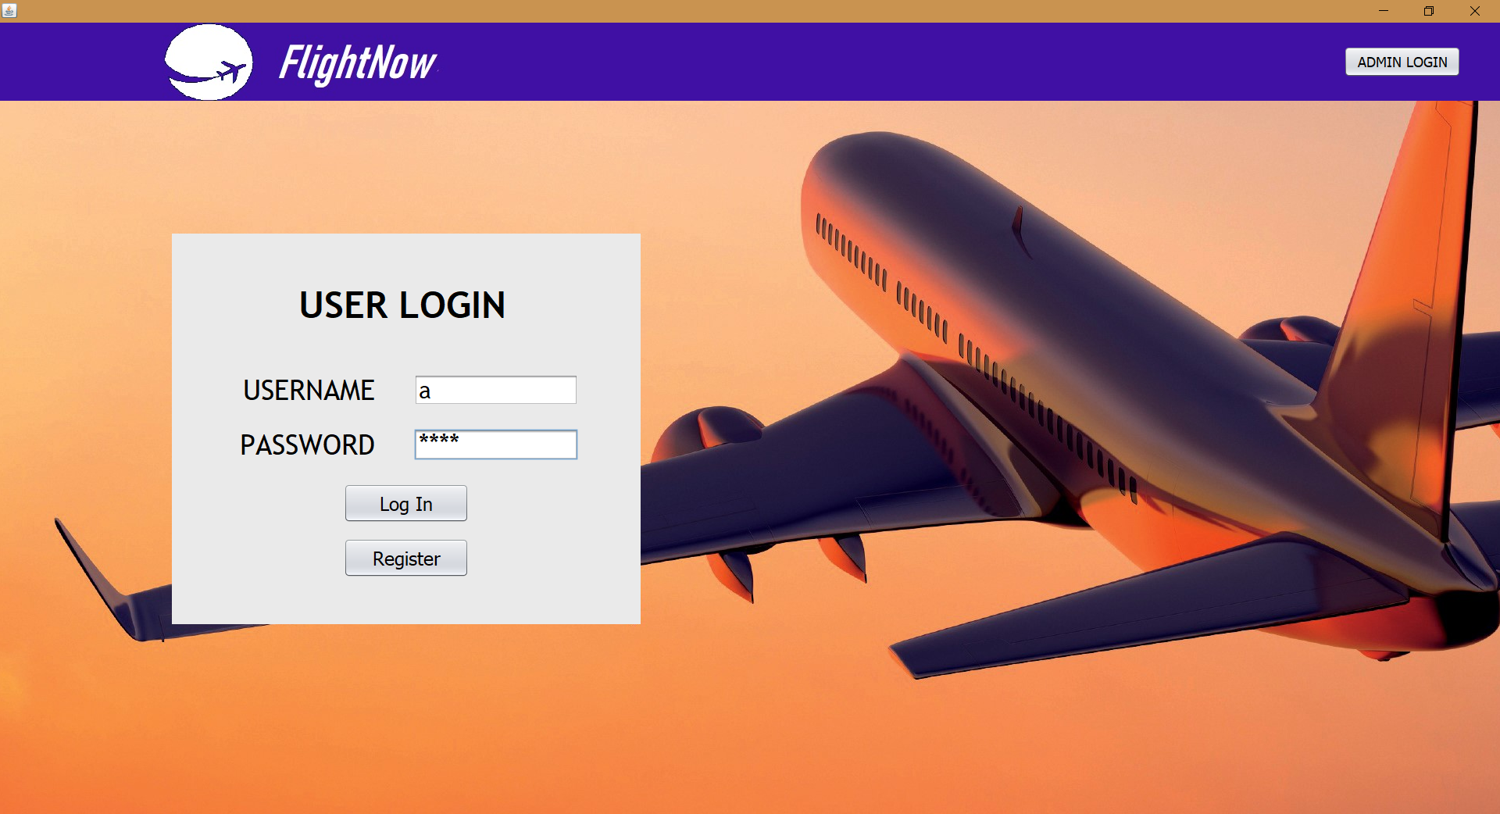

**User Home Page:**

Provides Login for User

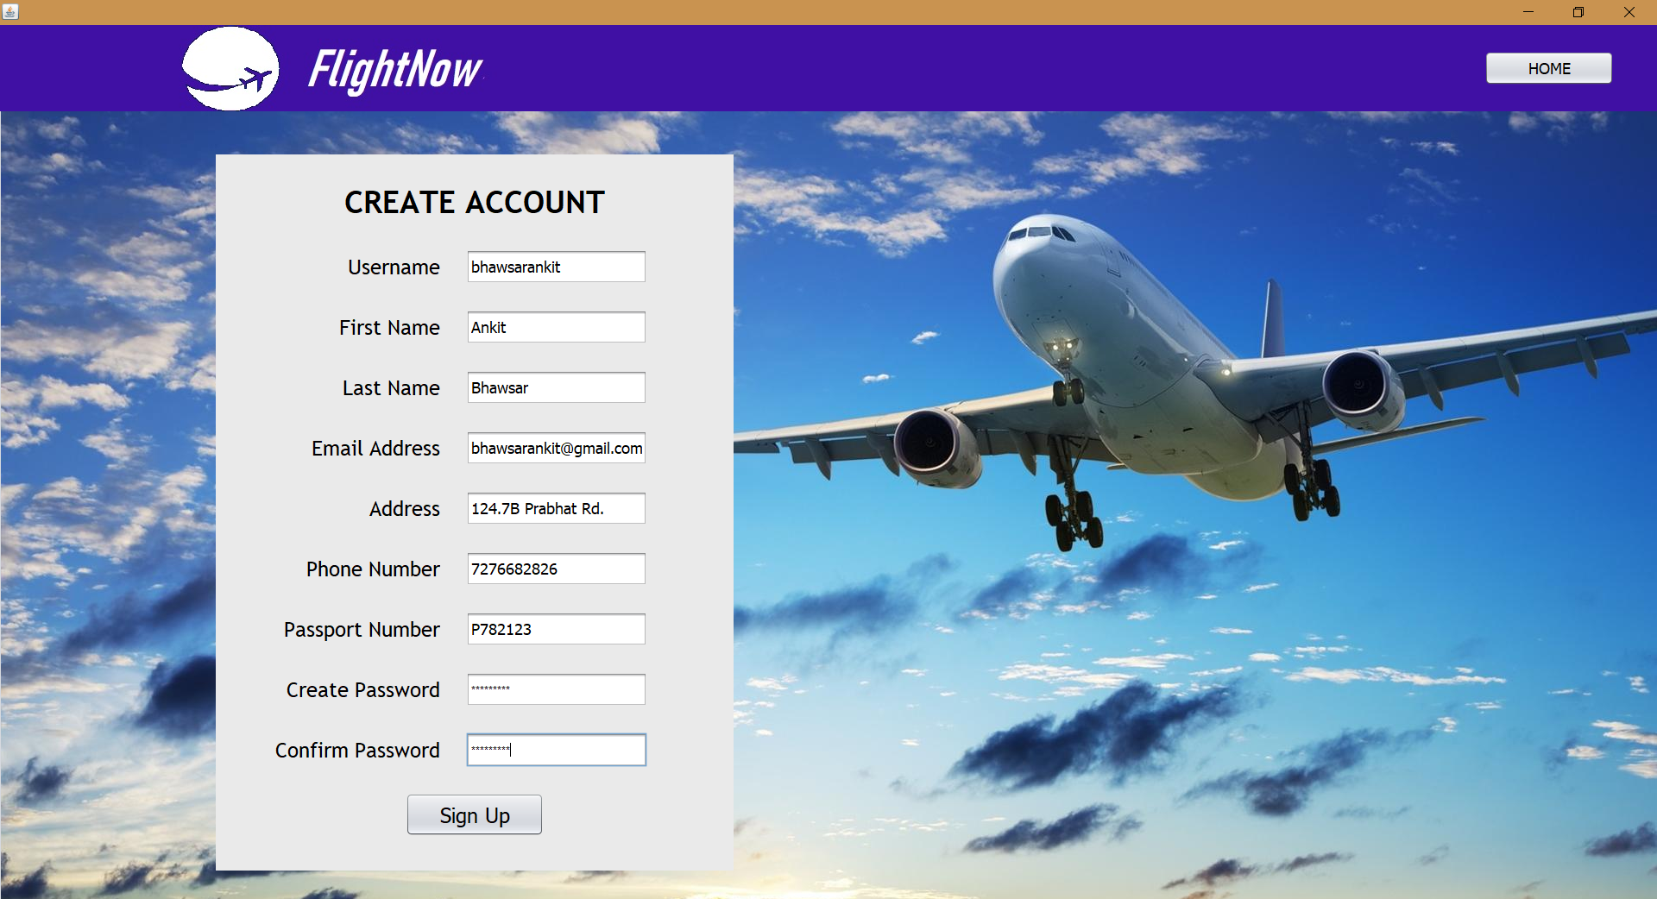

**User Register Page**

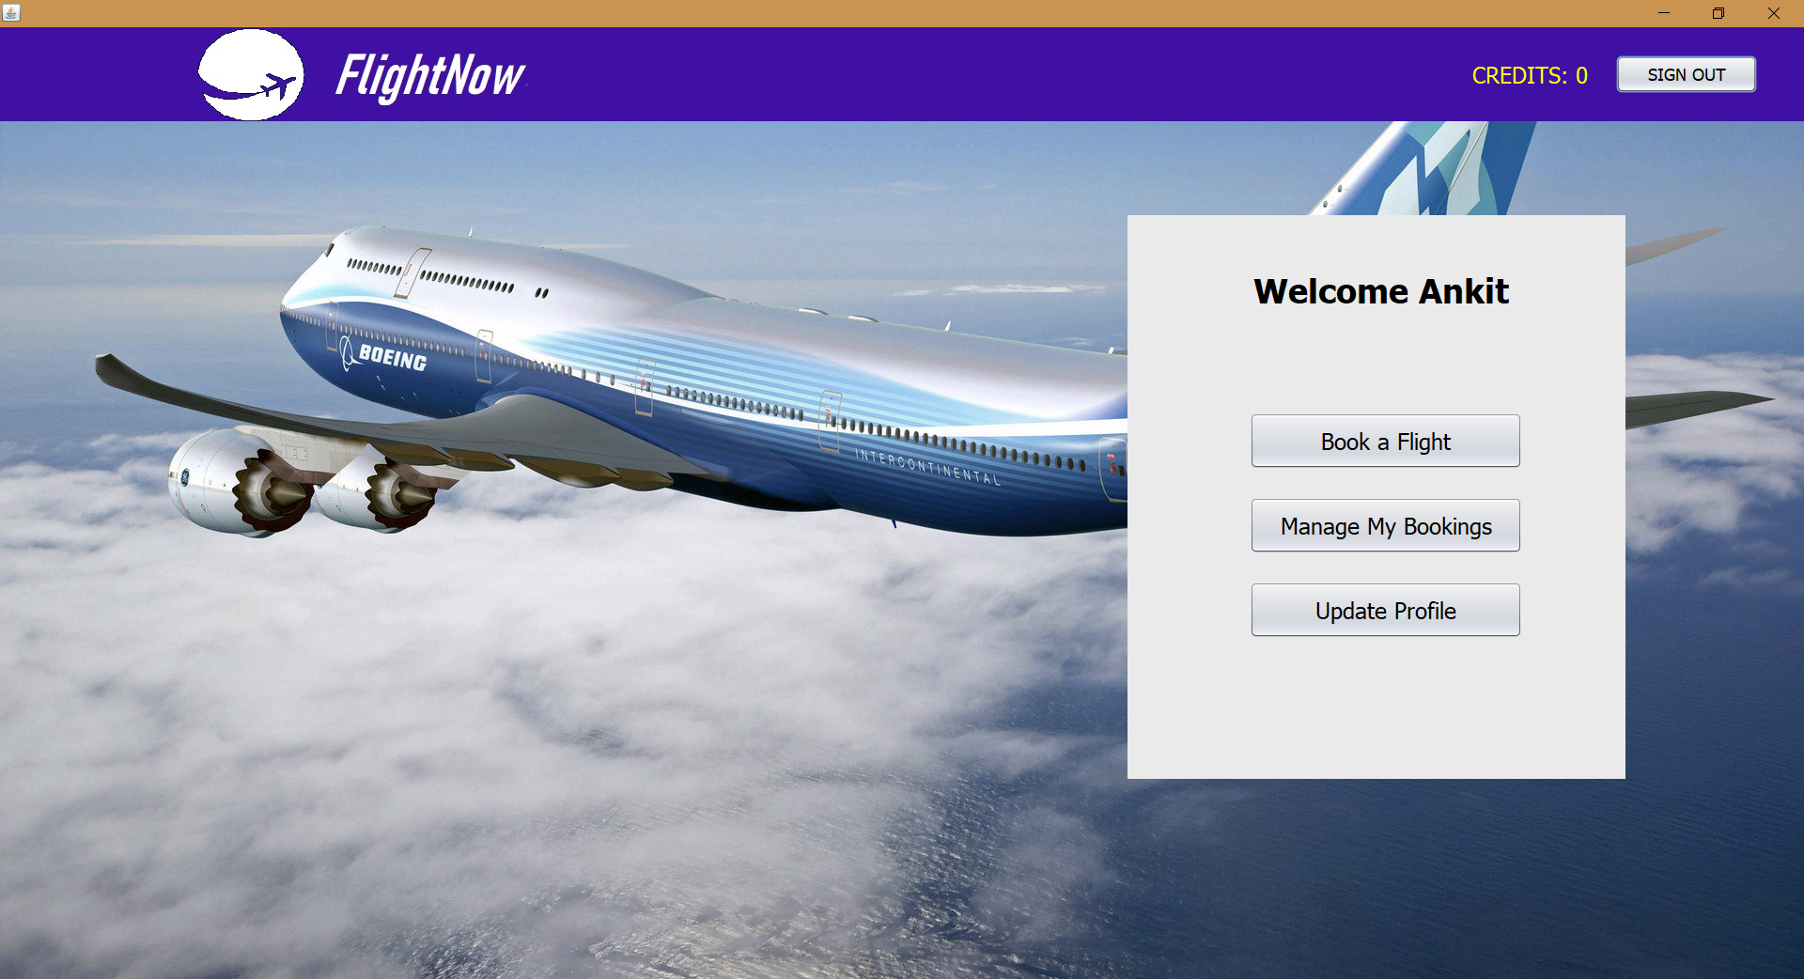

**User Home Page**:

Displays all functionalities to user

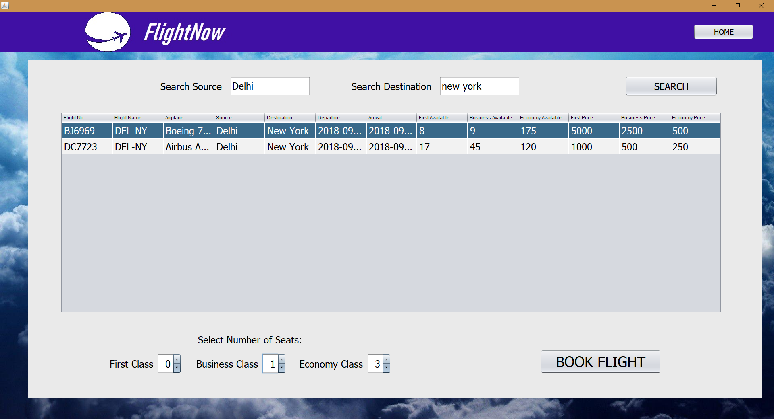

**Ticket Booking Page**:

Allows user to select and search for flights

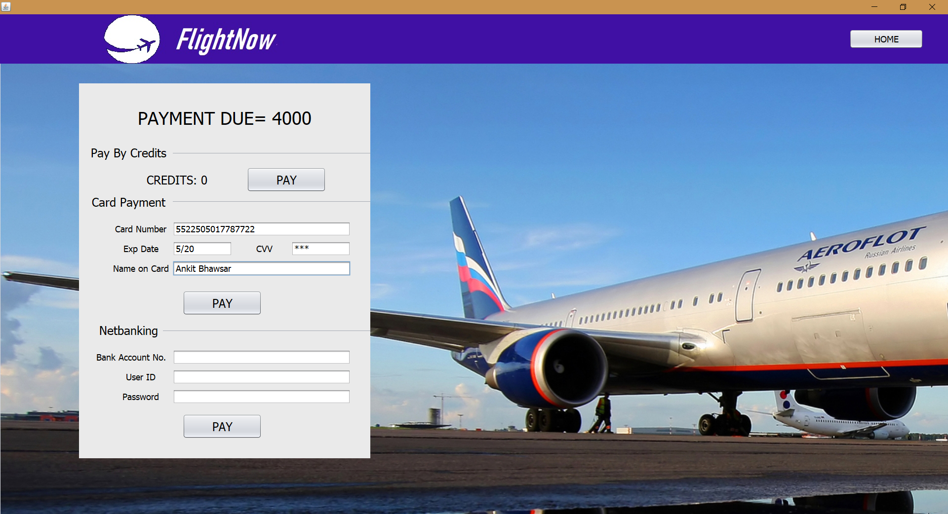

**Payment Page**:

Final payment with various available techniques

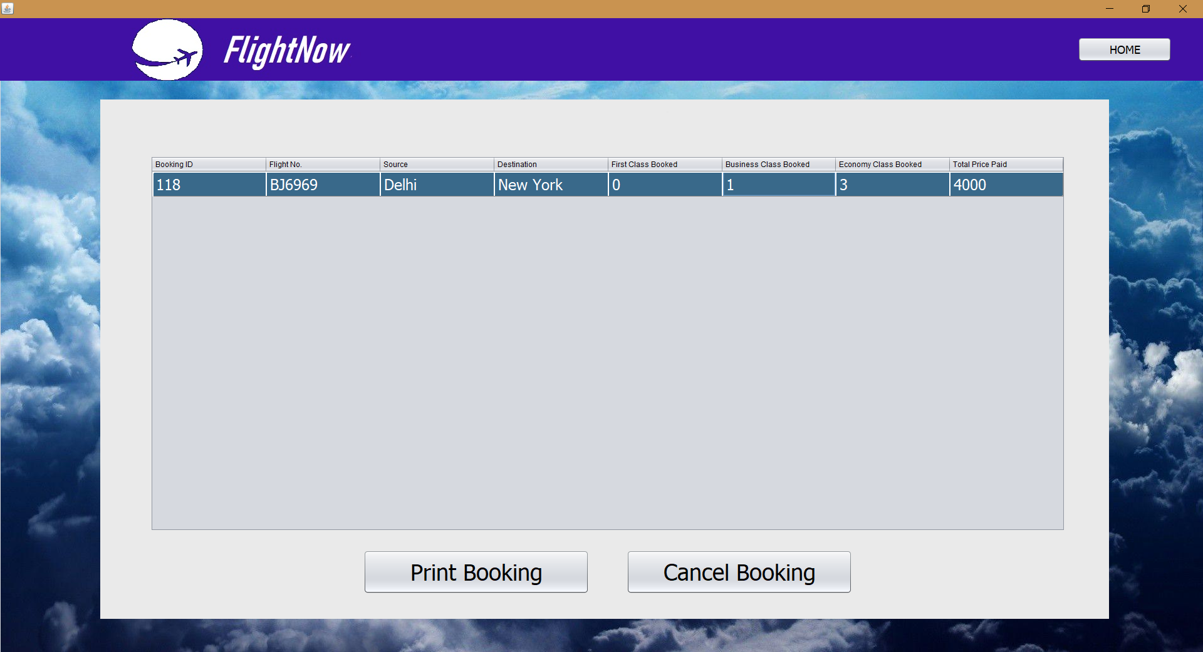

**Manage Bookings:**

Allows user to view, cancel or print tickets

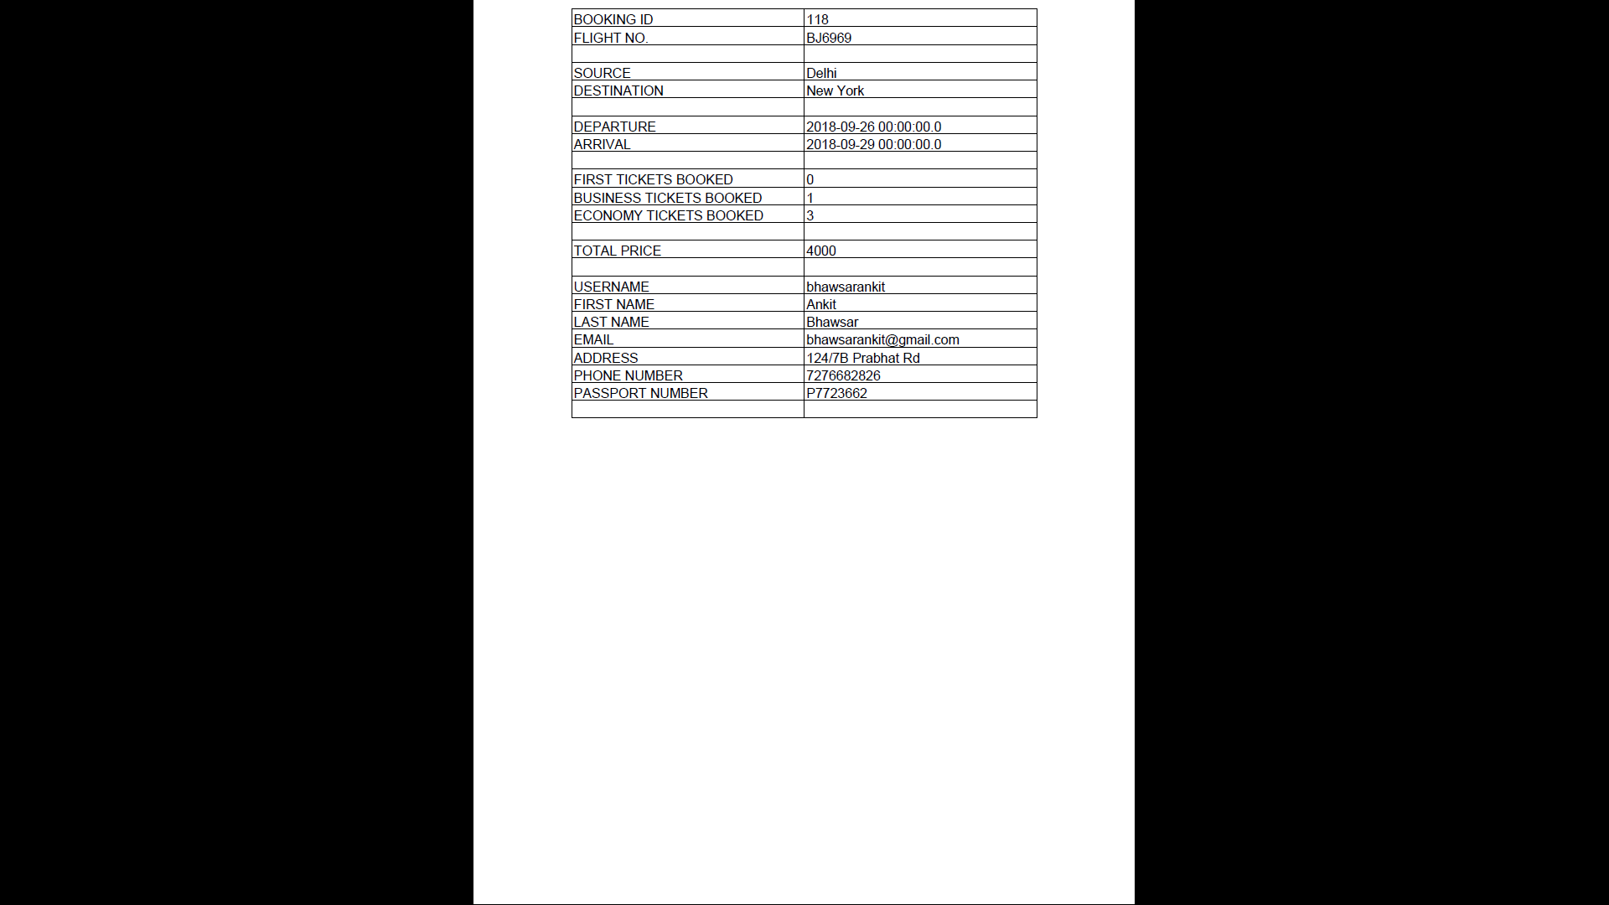

**Ticket Generated:**

PDF E-Ticket Generated after Payment Process

**7.2 Administrator Side GUI**

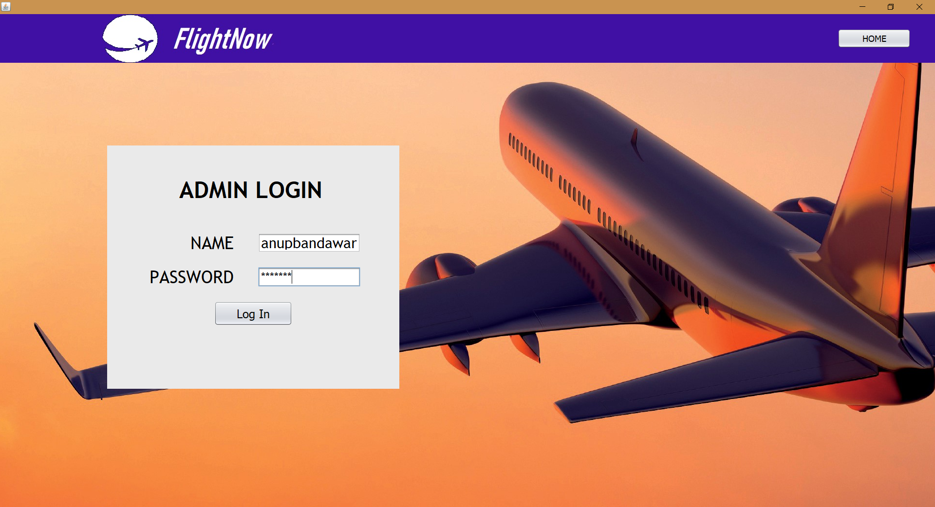

**Admin Login Page:**

Provides Login for Administrators

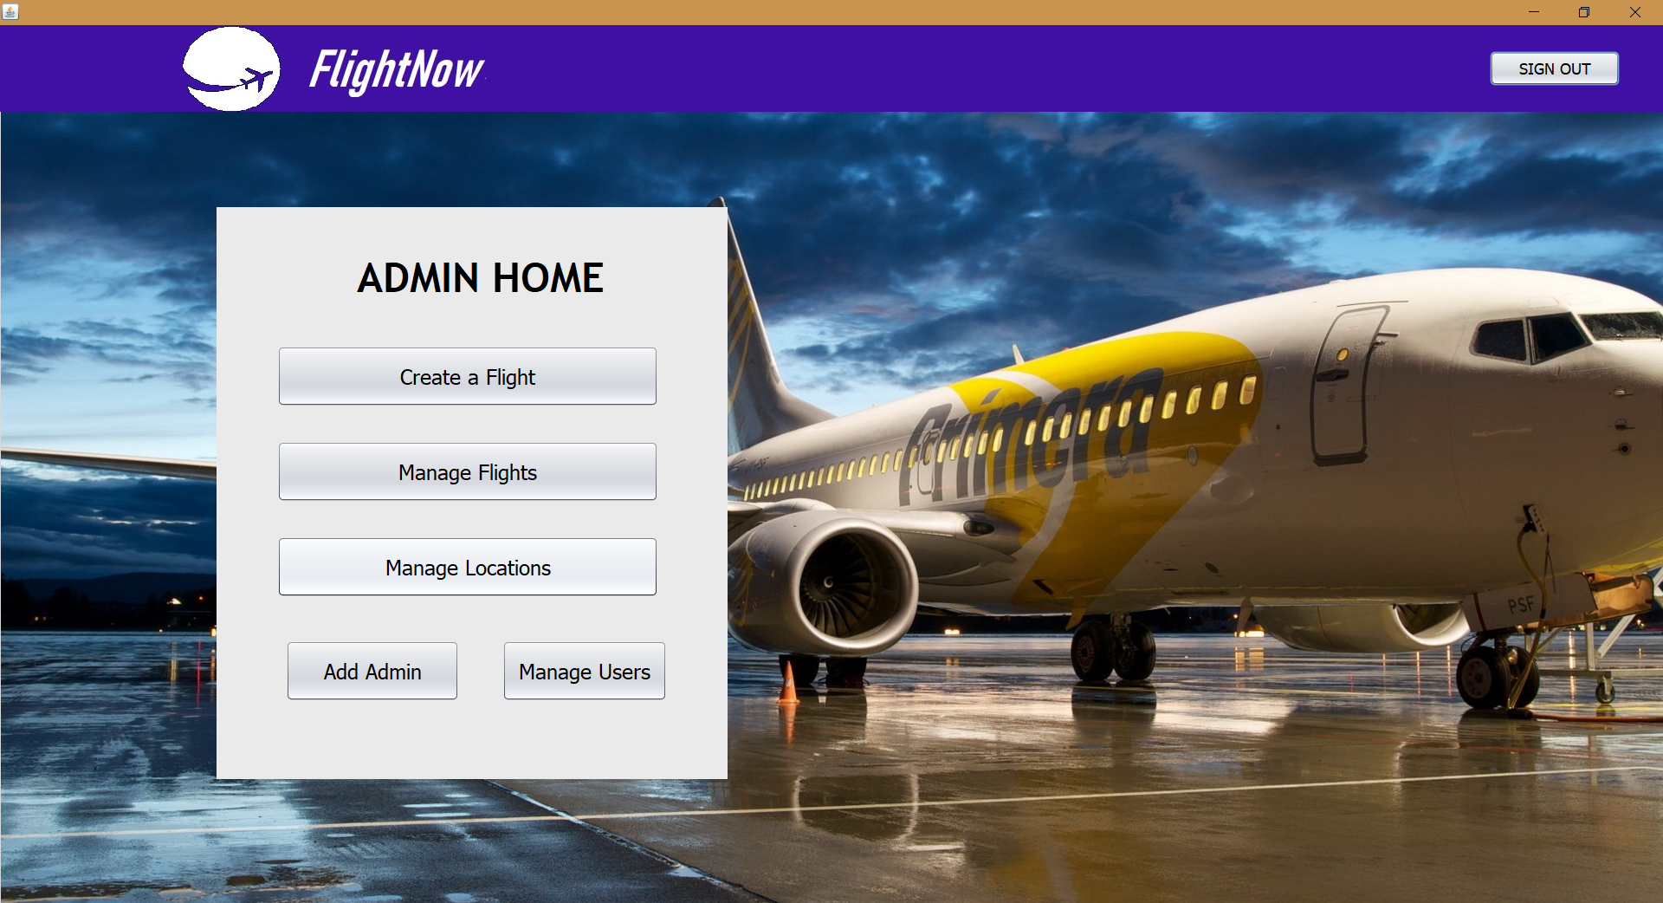

**Admin Home Page**:

Allows Admin to view all functionalities

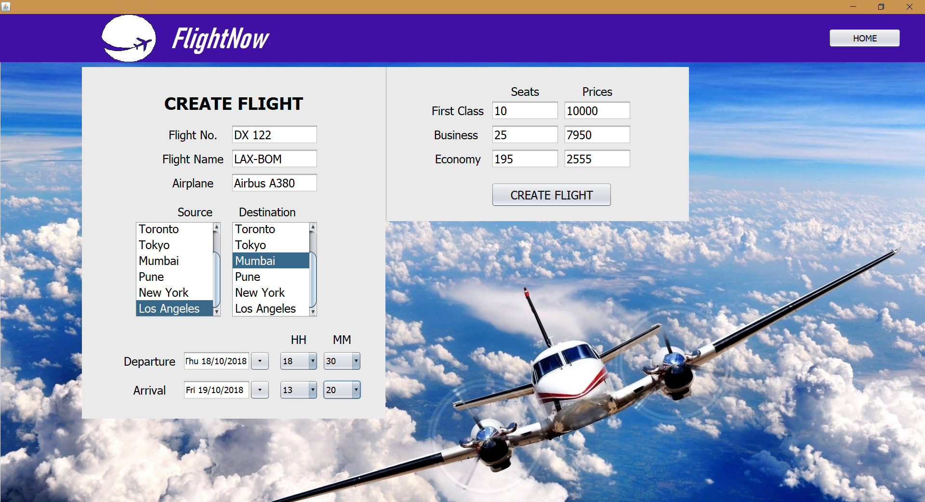

**Create Flight Page**:

Allows admins to create charter flights

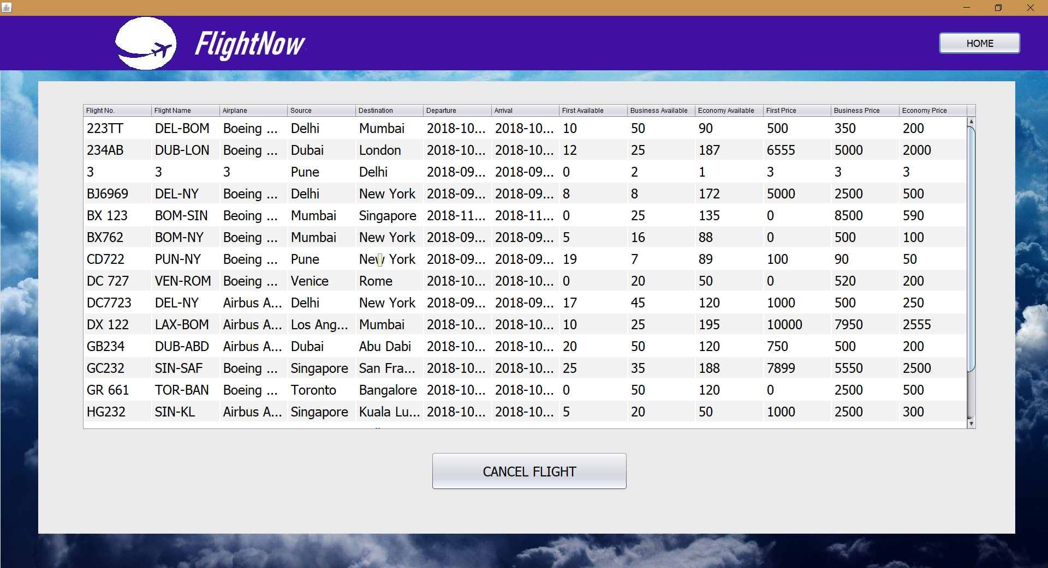

**Manage Flights Page**:

Allows Admin to view, cancel any flights

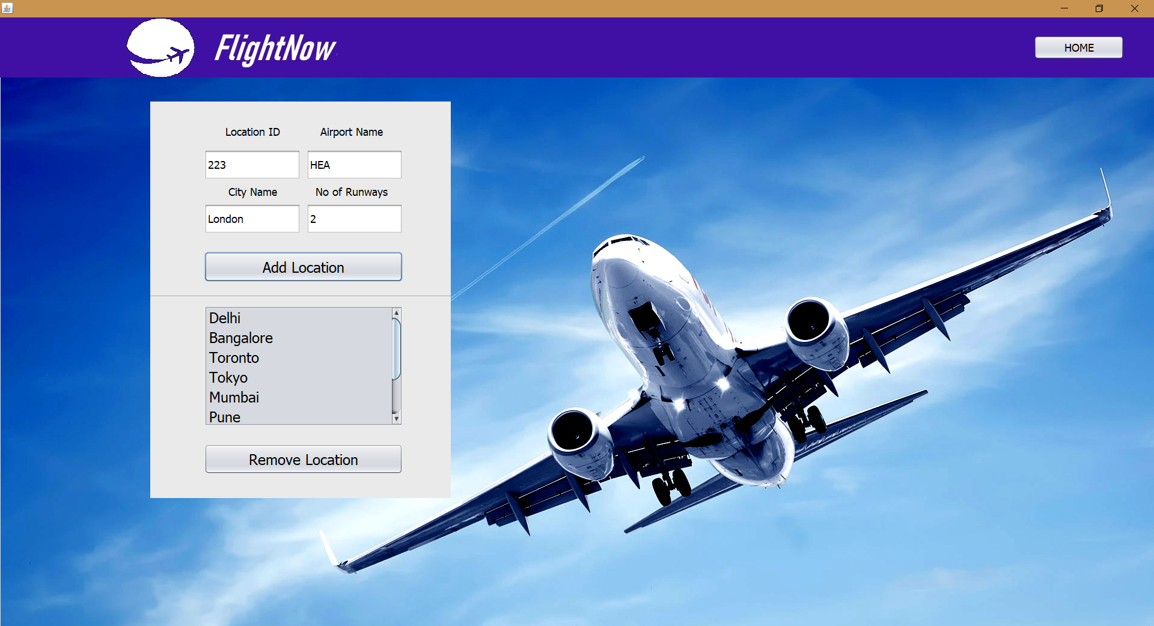

**Manage Locations**:

Allows admin to add or remove locations serviced by flight service

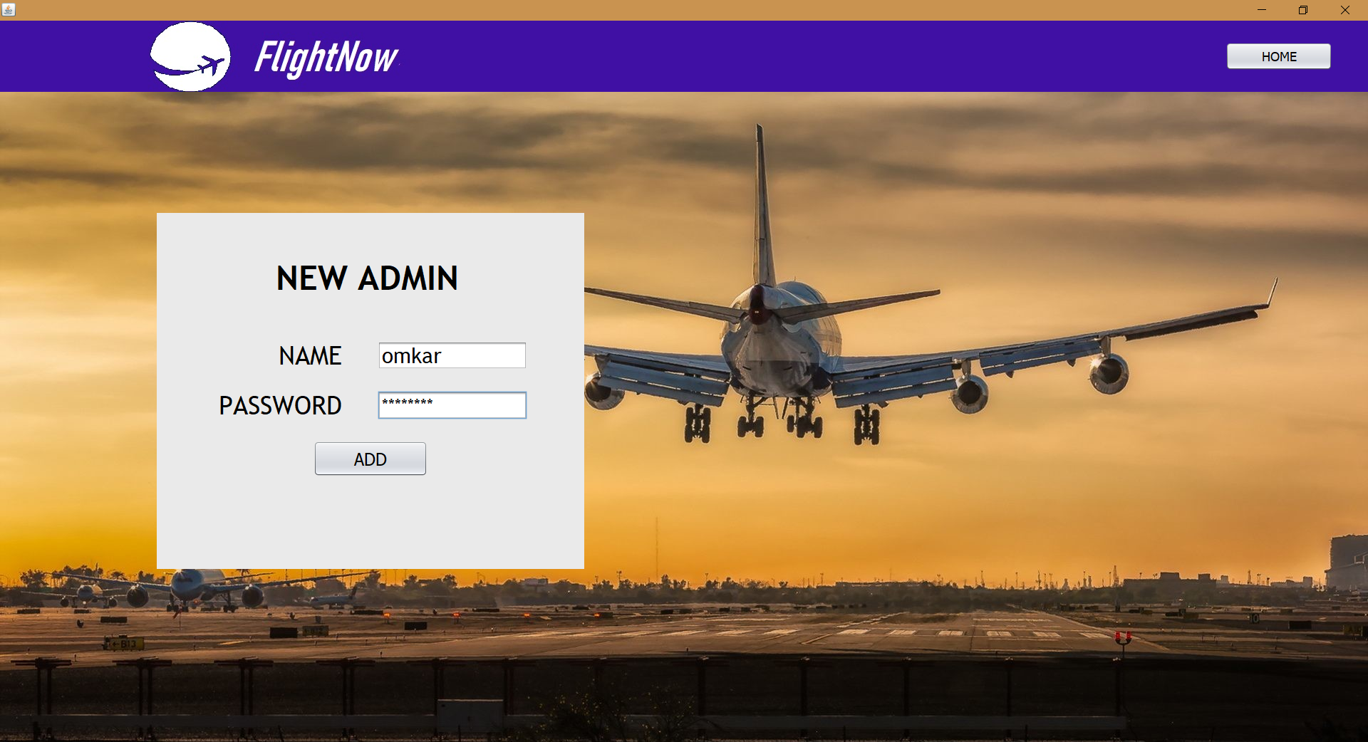

**Create Admin Page:**

Allows an admin to add another admin

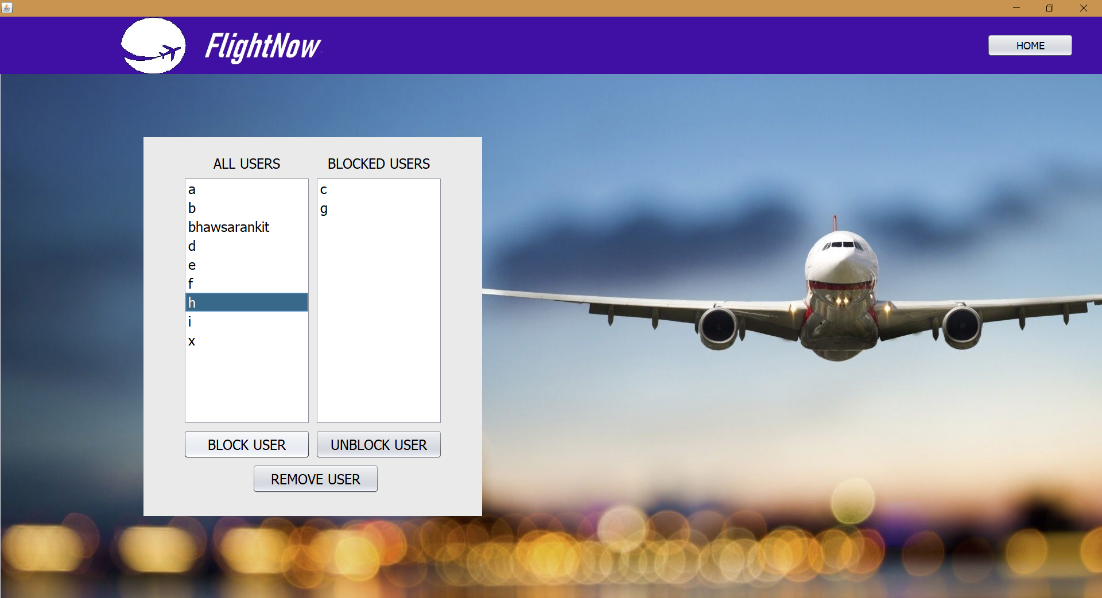

**Manage Users Page**:

Allows admin to block, unblock or remove users.

**10. SAMPLE CODE**

**HomePage.java**

Source Code for HomePage.java that provides login for user and options for admin login and user registration for new users:

package airlineproject;

import java.awt.Component;

import java.sql.Connection;

import java.sql.DriverManager;

import java.sql.PreparedStatement;

import java.sql.ResultSet;

import javax.swing.JOptionPane;

public class HomePage extends javax.swing.JFrame {

public HomePage() {

initComponents();

setExtendedState(java.awt.Frame.MAXIMIZED_BOTH);

}

@SuppressWarnings("unchecked")

// <editor-fold defaultstate="collapsed" desc="Generated Code">

private void initComponents() {

jLabel4 = new javax.swing.JLabel();

jLabel5 = new javax.swing.JLabel();

jLabel6 = new javax.swing.JLabel();

username1 = new javax.swing.JTextField();

user_password = new javax.swing.JPasswordField();

userregisterbutton = new javax.swing.JButton();

userloginbutton = new javax.swing.JButton();

jLabel3 = new javax.swing.JLabel();

jButton1 = new javax.swing.JButton();

jLabel2 = new javax.swing.JLabel();

jLabel1 = new javax.swing.JLabel();

setDefaultCloseOperation(javax.swing.WindowConstants.EXIT_ON_CLOSE);

setMaximumSize(new java.awt.Dimension(1920, 1080));

setMinimumSize(new java.awt.Dimension(1920, 1080));

setPreferredSize(new java.awt.Dimension(1920, 1080));

getContentPane().setLayout(null);

jLabel4.setFont(new java.awt.Font("Trebuchet MS", 1, 48)); // NOI18N

jLabel4.setHorizontalAlignment(javax.swing.SwingConstants.CENTER);

jLabel4.setText("USER LOGIN");

getContentPane().add(jLabel4);

jLabel4.setBounds(330, 340, 370, 40);

jLabel5.setFont(new java.awt.Font("Trebuchet MS", 0, 36)); // NOI18N

jLabel5.setHorizontalAlignment(javax.swing.SwingConstants.RIGHT);

jLabel5.setText("PASSWORD");

getContentPane().add(jLabel5);

jLabel5.setBounds(270, 520, 210, 40);

jLabel6.setFont(new java.awt.Font("Trebuchet MS", 0, 36)); // NOI18N

jLabel6.setHorizontalAlignment(javax.swing.SwingConstants.RIGHT);

jLabel6.setText("USERNAME");

getContentPane().add(jLabel6);

jLabel6.setBounds(270, 450, 210, 40);

username1.setFont(new java.awt.Font("Trebuchet MS", 0, 30)); // NOI18N

getContentPane().add(username1);

username1.setBounds(530, 450, 210, 40);

user_password.setFont(new java.awt.Font("Trebuchet MS", 0, 36)); // NOI18N

getContentPane().add(user_password);

user_password.setBounds(530, 520, 210, 40);

userregisterbutton.setFont(new java.awt.Font("Tahoma", 0, 24)); // NOI18N

userregisterbutton.setText("Register");

userregisterbutton.addActionListener(new java.awt.event.ActionListener() {

public void actionPerformed(java.awt.event.ActionEvent evt) {

userregisterbuttonActionPerformed(evt);

}

});

getContentPane().add(userregisterbutton);

userregisterbutton.setBounds(440, 660, 160, 50);

userloginbutton.setFont(new java.awt.Font("Tahoma", 0, 24)); // NOI18N

userloginbutton.setText("Log In");

userloginbutton.addActionListener(new java.awt.event.ActionListener() {

public void actionPerformed(java.awt.event.ActionEvent evt) {

userloginbuttonActionPerformed(evt);

}

});

getContentPane().add(userloginbutton);

userloginbutton.setBounds(440, 590, 160, 50);

jLabel3.setBackground(new java.awt.Color(0, 51, 102));

jLabel3.setFont(new java.awt.Font("SimSun", 0, 13)); // NOI18N

jLabel3.setIcon(new javax.swing.ImageIcon("C:\\Users\\admin\\Documents\\NetBeansProjects\\AirlineProject\\Pictures\\Silver.jpg")); // NOI18N

jLabel3.setText("jLabel3");

getContentPane().add(jLabel3);

jLabel3.setBounds(220, 270, 600, 500);

jButton1.setFont(new java.awt.Font("Tahoma", 0, 18)); // NOI18N

jButton1.setText("ADMIN LOGIN");

jButton1.addActionListener(new java.awt.event.ActionListener() {

public void actionPerformed(java.awt.event.ActionEvent evt) {

jButton1ActionPerformed(evt);

}

});

getContentPane().add(jButton1);

jButton1.setBounds(1720, 30, 150, 40);

jLabel2.setBackground(new java.awt.Color(0, 0, 102));

jLabel2.setHorizontalAlignment(javax.swing.SwingConstants.CENTER);

jLabel2.setIcon(new javax.swing.ImageIcon("C:\\Users\\admin\\Documents\\NetBeansProjects\\AirlineProject\\Pictures\\Header.jpg")); // NOI18N

jLabel2.setToolTipText("");

jLabel2.setRequestFocusEnabled(false);

getContentPane().add(jLabel2);

jLabel2.setBounds(0, 0, 1920, 100);

jLabel1.setHorizontalAlignment(javax.swing.SwingConstants.CENTER);

jLabel1.setIcon(new javax.swing.ImageIcon("C:\\Users\\admin\\Documents\\NetBeansProjects\\AirlineProject\\Pictures\\Wall1.jpg")); // NOI18N

jLabel1.setMaximumSize(new java.awt.Dimension(1920, 1080));

jLabel1.setMinimumSize(new java.awt.Dimension(1920, 1080));

jLabel1.setPreferredSize(new java.awt.Dimension(1920, 1080));

getContentPane().add(jLabel1);

jLabel1.setBounds(0, 0, 1920, 1080);

pack();

}// </editor-fold>

private void jButton1ActionPerformed(java.awt.event.ActionEvent evt) {

this.setVisible(false);

new AdminLogin().setVisible(true);

}

private void userregisterbuttonActionPerformed(java.awt.event.ActionEvent evt) {

this.setVisible(false);

new UserRegister().setVisible(true);

}

private void userloginbuttonActionPerformed(java.awt.event.ActionEvent evt) {

String name=username1.getText();

String pass=user_password.getText();

try{

Class.forName("com.mysql.jdbc.Driver");

Connection con=DriverManager.getConnection("jdbc:mysql://localhost:3307/airline_db","root","");

String sql="Select * from user where username=? and user_password= ?;";

PreparedStatement pst;

pst =con.prepareStatement(sql);

pst.setString(1,name);

pst.setString(2,pass);

ResultSet rs=pst.executeQuery();

boolean found=false,found2=false;

while(rs.next())

{

if(rs.getString("username").equalsIgnoreCase(name))

{

found=true;

if(rs.getString("user_password").equalsIgnoreCase(pass))

found2=true;

}

}

String query="select block_state from user where username=?";

PreparedStatement pst1;

pst1 =con.prepareStatement(query);

pst1.setString(1,name);

ResultSet rs1=pst1.executeQuery();

rs1.beforeFirst();

if(found == true && found2 == true)

{

while(rs1.next())

{

if((rs1.getInt("block_state")==0))

{

JOptionPane.showMessageDialog(this,"Successfully Logged In");

this.setVisible(false);

String makedeactive="update user set active_user=0";

PreparedStatement pst3;

pst3 =con.prepareStatement(makedeactive);

pst3.executeUpdate();

String makeactive="update user set active_user=1 where username=?;";

PreparedStatement pst2;

pst2 =con.prepareStatement(makeactive);

pst2.setString(1,name);

pst2.executeUpdate();

new UserHome().setVisible(true);

}

else{

JOptionPane.showMessageDialog(this,"Sorry, you have been Blocked!\nContact your Admin");

}

}

}

else if(found == false || found2 == false)

{

JOptionPane.showMessageDialog(this,"Incorrect Details");

}

}

catch(Exception r){

System.out.println(r);

}

}

/**

* @param args the command line arguments

*/

public static void main(String args[]) {

/* Set the Nimbus look and feel */

//<editor-fold defaultstate="collapsed" desc=" Look and feel setting code (optional) ">

/* If Nimbus (introduced in Java SE 6) is not available, stay with the default look and feel.

* For details see http://download.oracle.com/javase/tutorial/uiswing/lookandfeel/plaf.html

*/

try {

for (javax.swing.UIManager.LookAndFeelInfo info : javax.swing.UIManager.getInstalledLookAndFeels()) {

if ("Nimbus".equals(info.getName())) {

javax.swing.UIManager.setLookAndFeel(info.getClassName());

break;

}

}

} catch (ClassNotFoundException ex) {

java.util.logging.Logger.getLogger(HomePage.class.getName()).log(java.util.logging.Level.SEVERE, null, ex);

} catch (InstantiationException ex) {

java.util.logging.Logger.getLogger(HomePage.class.getName()).log(java.util.logging.Level.SEVERE, null, ex);

} catch (IllegalAccessException ex) {

java.util.logging.Logger.getLogger(HomePage.class.getName()).log(java.util.logging.Level.SEVERE, null, ex);

} catch (javax.swing.UnsupportedLookAndFeelException ex) {

java.util.logging.Logger.getLogger(HomePage.class.getName()).log(java.util.logging.Level.SEVERE, null, ex);

}

//</editor-fold>

/* Create and display the form */

java.awt.EventQueue.invokeLater(new Runnable() {

public void run() {

new HomePage().setVisible(true);

}

});

}

// Variables declaration - do not modify

private javax.swing.JButton jButton1;

private javax.swing.JLabel jLabel1;

private javax.swing.JLabel jLabel2;

private javax.swing.JLabel jLabel3;

private javax.swing.JLabel jLabel4;

private javax.swing.JLabel jLabel5;

private javax.swing.JLabel jLabel6;

private javax.swing.JPasswordField user_password;

private javax.swing.JButton userloginbutton;

private javax.swing.JTextField username1;

private javax.swing.JButton userregisterbutton;

// End of variables declaration

void setvisible(boolean b) {

throw new UnsupportedOperationException("Not supported yet."); //To change body of generated methods, choose Tools | Templates.

}

private Component UserHome() {

throw new UnsupportedOperationException("Not supported yet."); //To change body of generated methods, choose Tools | Templates.

}

}

**11. CONCLUSION**

This project has been developed and deployed to try and provide a better alternative to traditional methods of airline reservation systems. Keeping in mind the drawbacks of the old system, we have developed an Airline Reservation System which will provide user-friendly service to customers and help the user have a seamless process of booking airline tickets.

**12. REFERENCES**

1. www.mysql.com

2 .www.stackoverflow.com

3. www.extralectures.com

4. www.oracle.com